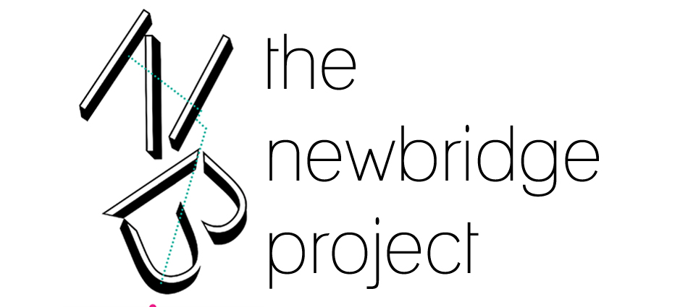

CALL FOR VOLUNTEERS
We’re looking for enthusiastic, energetic and eager volunteers to join our team at The NewBridge Project.
The NewBridge Project is a vibrant, artist-led studio community supporting artists’ practice and enabling critically engaged dialogue and writing. The volunteer programme offers a unique opportunity to work with us to deliver our exhibition programme, supporting emerging art practice by working closely with artists to develop innovative projects.

Our spaces include the NewBridge Project Space, a street level gallery space with a programme of regular exhibitions, screenings and events exploring new and diverse contemporary art practice. And NewBridge Books, a bookshop and social space that is unique to the region in offering diverse, original and hard-to-find national and international contemporary art publications. As a social space it provides a unique context to initiate and support opportunities to exchange ideas via a programme of regular discussion groups, meetings, performances and screenings.

As a volunteer, you'll share many of the advantages of a NewBridge Project member, joining our community of critically engaged artists, researchers and writers and accessing some of our shared spaces and facilities. In addition, there are opportunities to work with us on partner collaborations. You will also be welcome to join in with our member activities.

Volunteering at The NewBridge Project affords a unique insight into how artist-run organisations work, allowing volunteers to develop skills, networks and confidence within a supportive team.

We are currently offering the following exciting opportunities for volunteers (more information about these roles can be downloaded from the Volunteer page on our website):

Invigilation and Event Support
Exhibition Installation and Studio Maintenance
If you are interested in gaining experience in other areas, then don’t hesitate to get in touch. Depending on experience, we are sometimes able to offer opportunities in administration, marketing and social media amongst other things.

If you’re interested in volunteering with us, please complete the form below and email it back to us.

VOLUNTEER APPLICATION FORM

NAME:

EMAIL:

ADDRESS:

CONTACT TELEPHONE NO:

DOB:

OCCUPATION:

Are you interested in:

Gallery Invigilation and Event Assistance
Exhibition Installation and Studio Support and Maintenance
Both

1. Please tell us why you’d like to volunteer at The NewBridge Project.

2. What do you hope to get out of your volunteer experience?

3. Describe any skills or experience you have that you feel may be relevant.
What would you bring to the role?

4. Availability

Please give details about your availability for volunteering. Fill out Section a. for Invigilation and Event Assistance, and Section b. for Exhibition Installation and Studio Maintenance.

What days or times are you generally free?

- Invigilation Volunteers are required to commit to 6 hours of volunteering time every 2 weeks. Please state whether you would prefer:

One 3-hour shift weekly
One 6-hour shift every two weeks

If you would like to commit more time to volunteering at Newbridge then please provide further details here:

Would you also like to help with Event Assistance, and could you be available on occasional evenings and extra hours to do this?

Yes
No
- Exhibition Installation Volunteers are required to commit to 1-4 days of their time during exhibition installations.

Studio Support and Maintenance Volunteers are required to assist NewBridge staff with the maintenance and upkeep of the communal areas within our studio complex.

For both these roles NewBridge will contact you 2-3 weeks before install or work to enquire as to your availability.

On average, please state how many days you would be available, and if this sporadic shift pattern would work for you.

Please provide the name and contact telephone number for the person you would like us to contact in case of emergency.

Name:

Relationship:

Contact Number:

If you’d like to tell us about any disabilities or concerns that might prevent you from performing certain tasks, please use the space below.

Please let us know if you have any access requirements.

Please note that The NewBridge Project Volunteer Programme is open to applications from individuals aged 18 and over only.

If you have any questions about the volunteer programme or this application form, please don’t hesitate to get in touch. Please email this form back to Rebecca Huggan at:

Email: r.huggan@thenewbridgeproject.com

Phone: 0191 232 8975

Thank you for your interest in volunteering at The NewBridge Project!
